**CORE READS**

Below is a selection of reading books that we have chosen to help support & develop our children’s communication and language skills over the course of the academic year.

The titles, some of them classics, have been picked as they are repetitive and often feature rhyme.

Repetition of rhymes and stories is good for the brain, teaching children how language works and helps build memory capabilities.

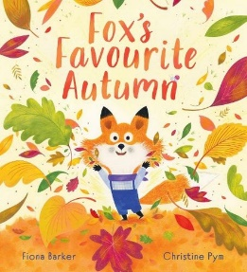**Autumn Term**

**Fox’s Favourite Autumn by Fiona Barker**

Autumn is Fox’s favourite time of year. As it slips away can he make it stay, A funny tale about the changing seasons whilst having consideration for others.

**The Gruffalo by Julia Donaldson**

No matter if you’re as big as a Gruffalo, or as small as a mouse, you can get out of any situation.

**Elmer by David McKee**

A classic story about Elmer the colourful patchwork elephant, different from the rest. This book offers opportunities to talk to the children about colour and how we are all different.

**Spring Term**

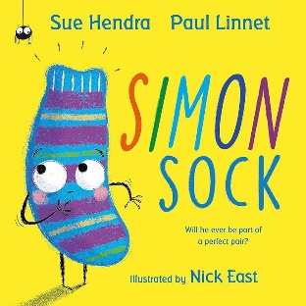

**Simon Sock by Sue Hendra**

Simon is an odd stripey sock who is looking for his perfect match whilst celebrating friendship, pattern and diversity.

**Above and Below by Patricia Hegarty**

From the rainforest to the ocean, Above and Below unveils different animals’ habitats on land and sea.

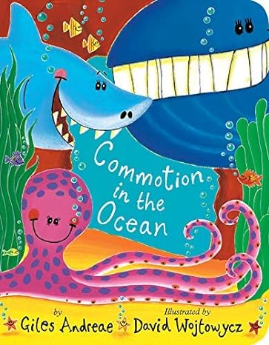**Commotion in the Ocean by Giles Andreae** Snappy poems and vibrant illustrations detail the different creatures who live in and around the ocean.

**Summer Term**

**Fox’s Socks by Julia Donaldson**

Fox’s Socks offers a simple rhyming storyline that talks about getting dressed.

**The Very Hungry Caterpillar by Eric Carle**

Teaches the days of the week, colours, counting and healthy eating.

**That’s My Flower by Alice Hemming**

Follow Squirrel through the book as he tries to protect the perfect flower that has sprung in Spring.

That’s My Flower explains the change in seasons whilst exploring feelings and moods.